
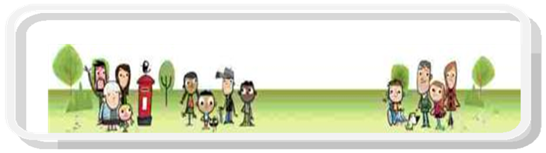

DSPL 9

Emotional Based School Absence
Support Package

Word versions of referral documents

Document | Page Number
Tier 3 Prior Information | 2
Tier 4 Referral Form | 4
Tier 3 Solution Circle Discussion Tool | 6
Tier 3 Solution Circle Evaluation | 7
Tier 3 Impact Feedback | 8
Tier 4: Parent Information document | 9
Parent/carer consent form | 10
SDQ | 12

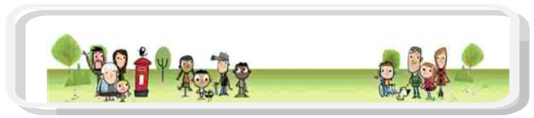

DSPL 9 EBSA Support Package

Tier 3: EBSA Solution Circle

Prior Information Document
Section 1:
Your name: | Role:
School:
Email address | Phone number:

Section 2:
Child’s name
Date of Birth: | Gender:
Year Group: | Attendance at school%:
Indication of where CYP is in relation to EBSA spectrum: | Occasional Avoidance
Indication of where CYP is in relation to EBSA spectrum: | Intermittent Avoidance
Indication of where CYP is in relation to EBSA spectrum: | Frequent Avoidance
Reduced timetable information (if appropriate):

Parent’s name: | Relationship to CYP:
Parent email address: | Parent phone number:
Is the parent accessing the DSPL 9 EBSA Parent Support Group? Yes/No

Section3:
Please describe the current situation in relation to EBSA, its impact on the child/family/education; identified risks and other concerns.
Other agencies involved with the family (and duration if known):
Name of service/agency | Reason for input and duration if known
Parents view and comments:
CYP views and comments (if appropriate)
What outcomes would you like as a result of this referral/support?
School:

Parents:

CYP:

SENCo signature |  | Parent signature
Date |  | Date

Please ensure this referral and supporting evidence is sent via schoolsfx to admin@dsplarea9.org.uk clearly titled as DSPL 9 EBSA Tier 3 referral

Tier 3 Solution Circle Check list
Must include | Tick if attached to this document
Attendance at EBSA training session (or booked on to attend one of the sessions)
Evidence of personalised and holistic plan
Evidence of pupil voice
Evidence of reduced timetable (if appropriate)

Please ensure the above documents are attached to the prior information form and shared as part of the referral.

DSPL 9 EBSA Support Package
Tier 4: EBSA 1:1 Child Support
Referral Form
Section 1:
Your name: | Role:
School:
Email address | Phone number:

Section 2:
Child’s name
Date of Birth: | Gender:
Year Group: | Attendance at school%:
Indication of where CYP is in relation to EBSA spectrum: | Occasional Avoidance
Indication of where CYP is in relation to EBSA spectrum: | Intermittent Avoidance
Indication of where CYP is in relation to EBSA spectrum: | Frequent Avoidance
Reduced timetable information (if appropriate):

Parent’s name: | Relationship to CYP:
Parent email address: | Parent phone number:
Is the parent accessing the DSPL 9 EBSA Parent Support Group? Yes/No

Section3:
Please describe the current situation in relation to EBSA, its impact on the child/family/education; identified risks and other concerns.
Other agencies involved with the family (and duration if known):
Name of service/agency | Reason for input and duration if known
What outcomes would the child/young person like as a result of this referral/support?
What outcomes would the parents like as a result of this referral/support?
What outcomes would the school like as a result of this referral/support?

SENCo signature |  | Parent signature |  | CYP signature
Date |  | Date |  | Date

Please ensure this referral and supporting evidence is sent via schoolsfx to admin@dsplarea9.org.uk clearly titled as DSPL 9 EBSA Tier 4 referral
Tier 4 Check list
Must include | Tick if attached to this document
Attendance at EBSA training session (or booked on to attend one of the sessions)
Evidence of personalised and holistic plan
Evidence of pupil voice
(assessments)
Evidence of collaborative working with parents
Evidence of reduced timetable (if appropriate)
Evidence of attendance and impact of solution circles (tier 3)
Completion (including scoring) of an SDQ

Please ensure the above documents are attached to the prior information form and shared as part of the referral.

DSPL 9 EBSA Support Package

Tier 3: EBSA Solution Circle Discussion Tool
Section 1:
Child’s name | DOB:
School:

Section 2:
Date of solution circle:
In attendance:

Section3:
Present issue:
Team ideas/solutions:
Discussions:
Next steps:

DSPL 9 EBSA Support Package

Tier 3: EBSA Solution Circle Evaluation
Section 1:
Your name: | Role:
School:

Section 2:
 | Excellent  1 | Good  2 | Satisfactory  3 | Unsatisfactory  4
- How useful was the solution circle?
- How well did the professionals support you during the solution circle?
- To what extent do you feel you acquired additional strategies as a result of attending the solution circle?
- How confident are you in using/delivering these additional strategies?

Section3:
What did you find the most interesting/useful? | What did you find the least interesting/useful/lacking?
What would you like to know more about?

DSPL 9 EBSA Support Package
Tier 3: EBSA Solution Circle
Impact Feedback
Section 1:
Your name: | Role:
School:

Section 2:
Child’s name
Date of Birth: | Gender:

Section3:
Attendance at time of solution circle:
Current attendance %:
Reduced timetable status:

Impact of additional strategies:

DSPL 9 EBSA Support Package
Tier 4: Parent Information
What is EBSA?
Emotionally Based School Absence/Avoidance (EBSA) refers to reduced or non-school attendance by a child or young person due to multiple factors. The avoidance or absence is rooted in emotional, mental health and well-being factors (Anna Freud Centre,2023).

Below we have listed different sources with further information for families and carers.
For further information on the Hertfordshire Local Offer click here.
The Anna Freud Centre has many resources to support families. Click here
For an easy-to-understand Youtube video click explaining EBSA, click here

DSPL 9 Support Package
Here in DSPL 9, we have recognised that EBSA continues to be an issue for many of our children and young people. In response to this, we have developed a support package to enable schools, parents and children to seek local support and work collaboratively to overcome the many barriers that lead to EBSA.

Your son or daughter has been identified by the school as experiencing EBSA and therefore eligible to access support through the DSPL 9 EBSA Support Package.

What does this mean?
Your son/daughter, you as a parent and the school will be supported over a 12-week period by the following professionals:
- Nessie Therapist: Supporting your child to work through the issues leading to EBSA and providing strategies and ideas to be able to understand EBSA and learn to cope better.
- Family Support Worker (FSW): Supporting you to consider how you can best support your child to overcome his/her emotionally based school absence.
- DSPL 9 Manager and SEND Lead: Supporting the school to ensure they are working collectively with the above agencies and providing support from a school perspective.
This work will form a triangulated approach encompassing all aspects of the child’s EBSA.

How will this happen?
- Initially, you will be contacted by the Nessie Therapist and FSW to arrange a meeting to consider how the support will work, what assessments will need to be carried out, and any initial next steps/actions.
- You will meet on a weekly basis for 10 weeks with the FSW following the initial meeting.
- Your child will have weekly one-hour sessions with the Nessie Therapist at school. It is important the child is supported to attend these sessions outside of their teaching/ timetabling.
- The school will meet with the DSPL 9 Manager on weekly basis.
- At the 12th week, all those involved (including yourself) will attend a meeting to consider the impact of the support and any next steps.

What if I have any questions during the support?
You will be able to ask your FSW any questions you have when you meet or alternatively contact Gemma Hall (DSPL 9 Manager and SEND Lead) on gemmahall@dsplarea9.org.uk

For further information about Nessie please click here.
For further information about the Family Support Workers please click here.
For further information about DSPL 9 please click here.

DSPL 9
Consent to support from the EBSA Support Package: Tier 4

Name of child/young person:……………………………………………………

Known as: …………………………………………….

Address: ………………………………………………………………………………………………………………………………………………………………..

…………………………………………………………………………………................................................................................................

Date of Birth:………………………………………………………………………

School/s (if applicable): ……………………………….

Year/s in School (if applicable)………………………………………………..

Emergency contact number…………………………………….

Emergency contact email ……………………………………..

Name of contact ………………………………………………………………….

Relationship to named above ………………………………………………………………

The team around the family will be working closely with different professionals as well as schools. This helps our services to meet the needs of individual children, young people and their families.

We may need to share information about you and your family and also ask for information from professionals that will assist us to understand your situation. We need your consent before we contact professionals.

You may withdraw consent to information sharing at any time by informing us in writing you wish to withdraw consent. You may also ask for the information shared to be conditional, for instance if there is someone you don’t want us to share your information with or obtain information from.

Any details of the services we provide or information about you or your family will be stored and used in strict accordance with our registration under the Data Protection Act 1998.

You do not have to consent to information sharing but this may make it difficult to provide the services that you or your family need. You should also know that we have a legal duty to share information with other agencies if we believe it will protect you, prevent harm to someone else or prevent/detect a crime.

If we use your information for other reasons, for example to plan our services or do research, then we will make sure
that you cannot be identified.

We will not use your information for staff training without asking you for specific consent at the time.

I give consent for the person named above to take part in sessions with a Nessie Practitioner (including Trainee Clinical Psychologist):
Yes ☐
No ☐
I consent for DSPL 9/NESSie/SWHP to share and receive personal information, for the purpose of supporting the named above if needed, with the following named professional/s:
School / education setting Yes ☐ No ☐

Hertfordshire County Council
(Including DSPL, ISL, SEN & Children’s services) Yes ☐ No ☐

Behaviour support services Yes ☐ No ☐

Medical professionals
(including GP, CDC, CAMHS, Step2, Educational psychologist & PALMS) Yes ☐ No ☐

By signing below I give consent for DSPL 9/NESSie/SWHP to store data electronically and in paper form, as appropriate (please see NESSie Privacy Policy for further information). Anonymous data may be shared by DSPL 9/NESSie/SWHP with commissioners of Hertfordshire and the Department of Health to help inform and improve wellbeing services. Parents / carers / persons can retract permission for us to hold personal information at any time by contacting the following: gemmahall@dsplarea9.org.uk

I give consent for support from a DSPL 9/NESSie/SWHP.

Name: ...…………………………………………………………...........................

Signature:……………………………………………… Date:………………………

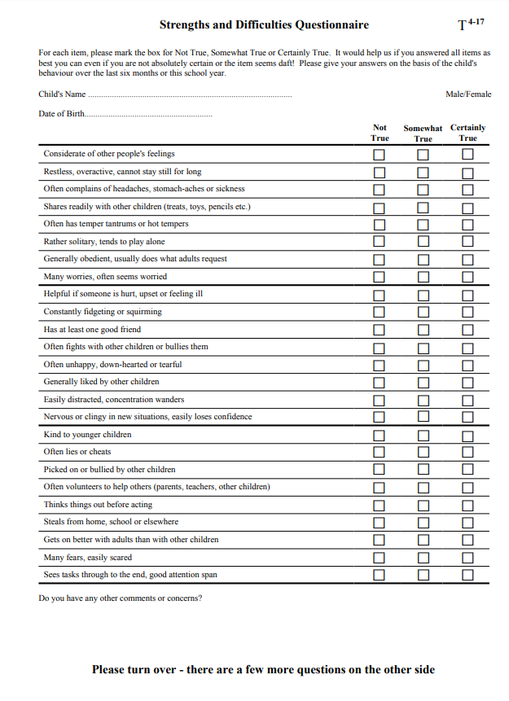

(Electronic copies via here)



